EXPERIMENT NO. 21

Containerizing a Python Flask To-Do Application Using Docker

Aim
To develop a simple Python Flask To-Do application, containerize it using Docker, run it locally, test its functionality, and push the Docker image to Docker Hub.

Software Requirements
- Windows 10/11 (or Linux/macOS)
- Python 3.x
- Docker Desktop
- Visual Studio Code (or any code editor)
- Web Browser
- Docker Hub Account

Theory
Flask is a lightweight Python web framework used for developing web applications. Docker packages the Flask application and its dependencies into a container, allowing it to run consistently on any system. The Docker image can also be uploaded to Docker Hub for sharing and deployment.

Procedure
Step 1: Create the Project Folder
Create a folder named flask-todo-app. Inside the folder, create the following files:
- app.py
- requirements.txt
- Dockerfile
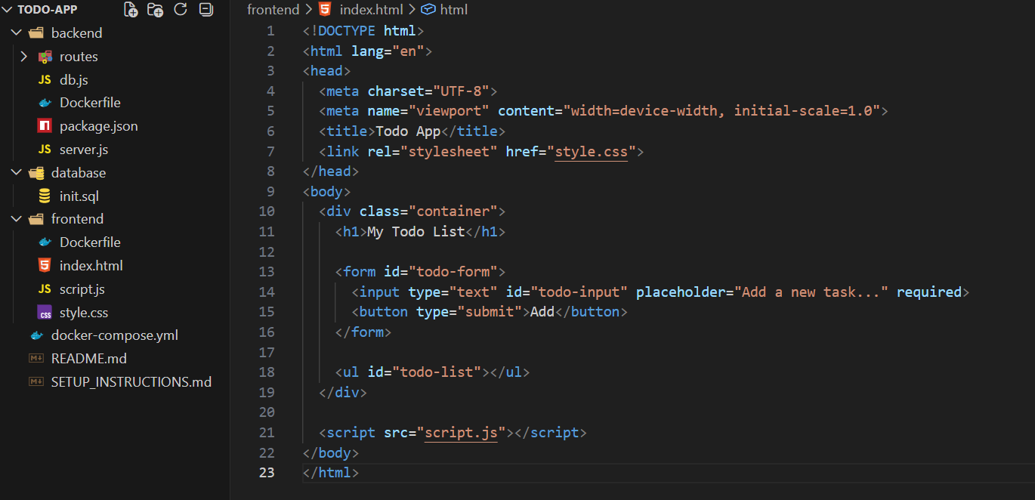
Step 2: Create the Flask Application
Create app.py.
from flask import Flask
app = Flask(__name__)
@app.route('/')
def home():
return """
<h2>To-Do List</h2>
<ul>
<li>Complete Docker Lab</li>
<li>Practice Flask</li>
<li>Push Image to Docker Hub</li>
</ul>
"""
if __name__ == "__main__":
app.run(host="0.0.0.0", port=5000)

Step 3: Create the Requirements File
Create requirements.txt.
Flask

Step 4: Create the Dockerfile
Create Dockerfile.
FROM python:3.11-slim
WORKDIR /app
COPY requirements.txt .
RUN pip install --no-cache-dir -r requirements.txt
COPY . .
EXPOSE 5000
CMD ["python", "app.py"]
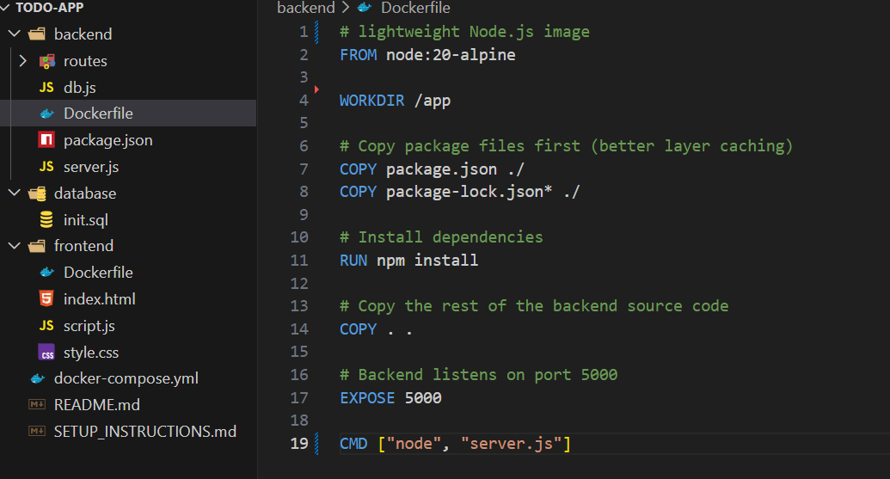

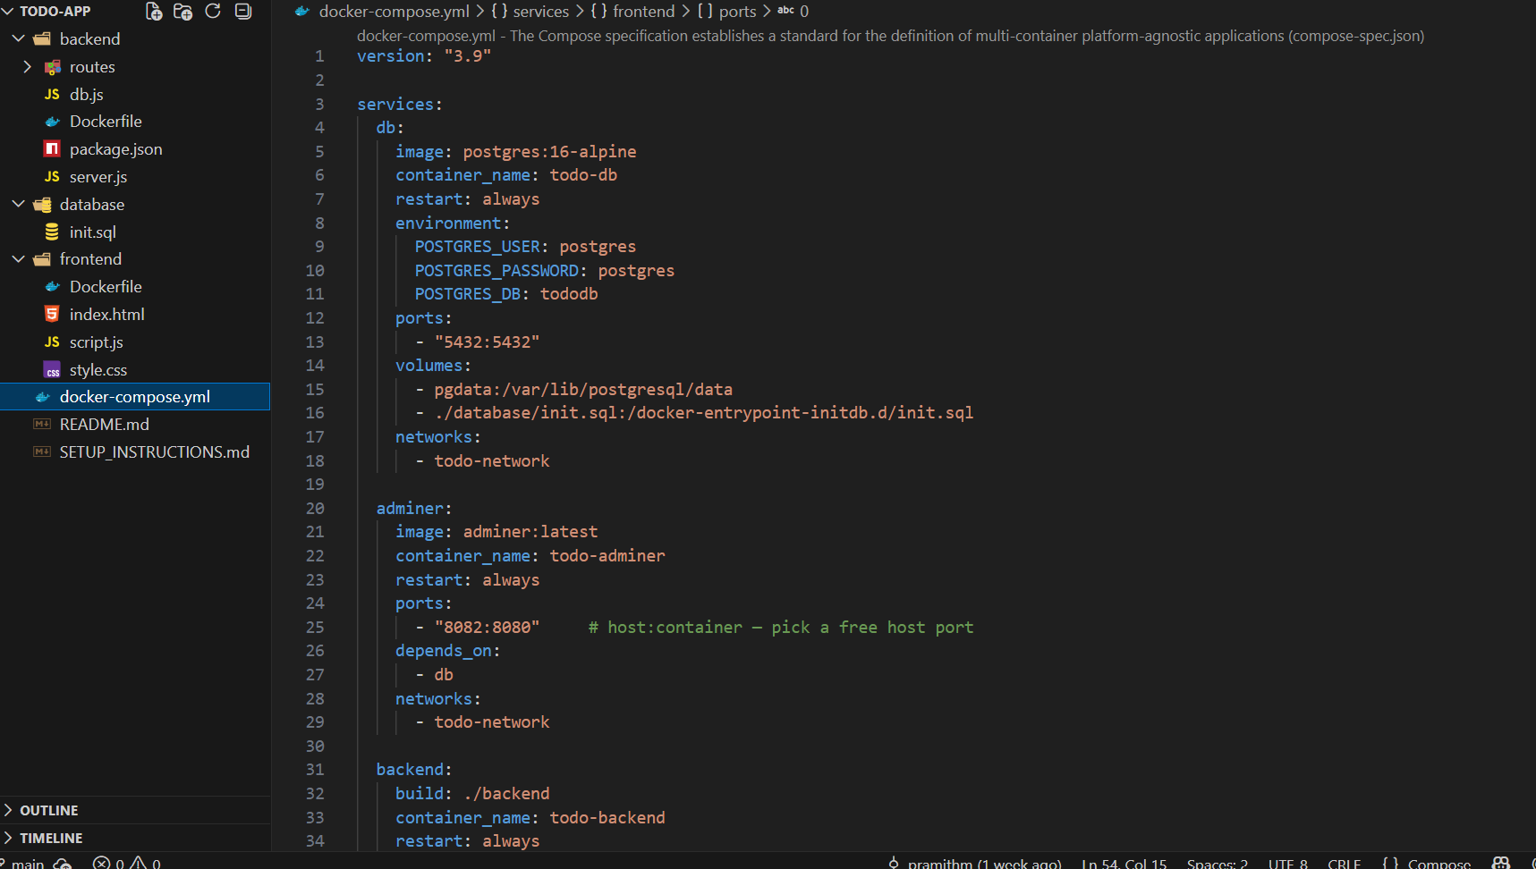
Step 5: Build the Docker Image
Open Terminal or Command Prompt in the project folder.
docker build -t flask-todo .

Step 6: Run the Docker Container
docker run -d -p 5000:5000 --name flask-todo-container flask-todo
Or using Docker compose you can build
Verify the running container.
docker ps

Step 7: Test the Application
- Open a web browser.
- Navigate to: http://localhost:3001
- Verify that the To-Do list page is displayed successfully.

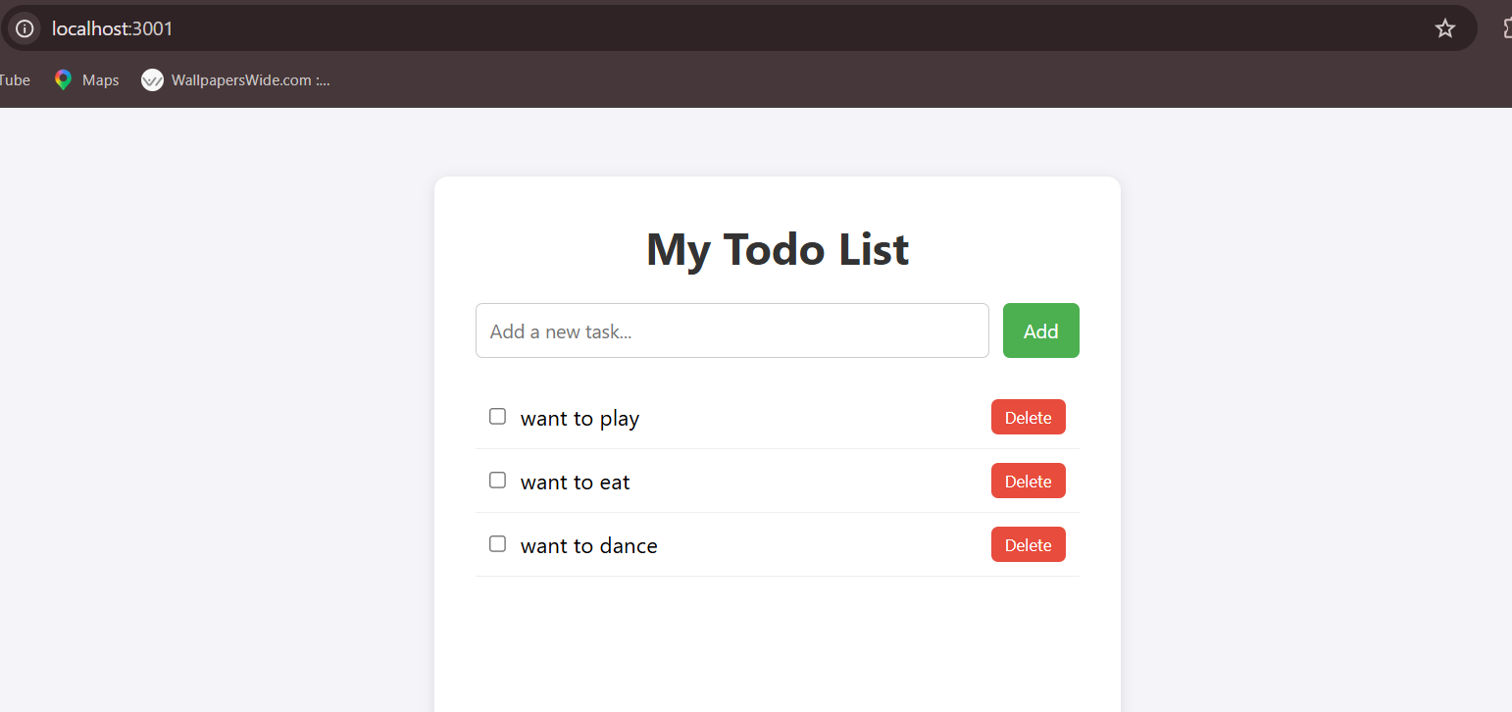
Step 8: Login to Docker Hub
docker login

Enter your Docker Hub username and password.
Step 9: Tag the Docker Image
Replace yourusername with your Docker Hub username.
docker tag flask-todo yourusername/flask-todo:latest

Step 10: Push the Image to Docker Hub
docker push yourusername/flask-todo:latest

Wait until the image is uploaded successfully.

Screenshots
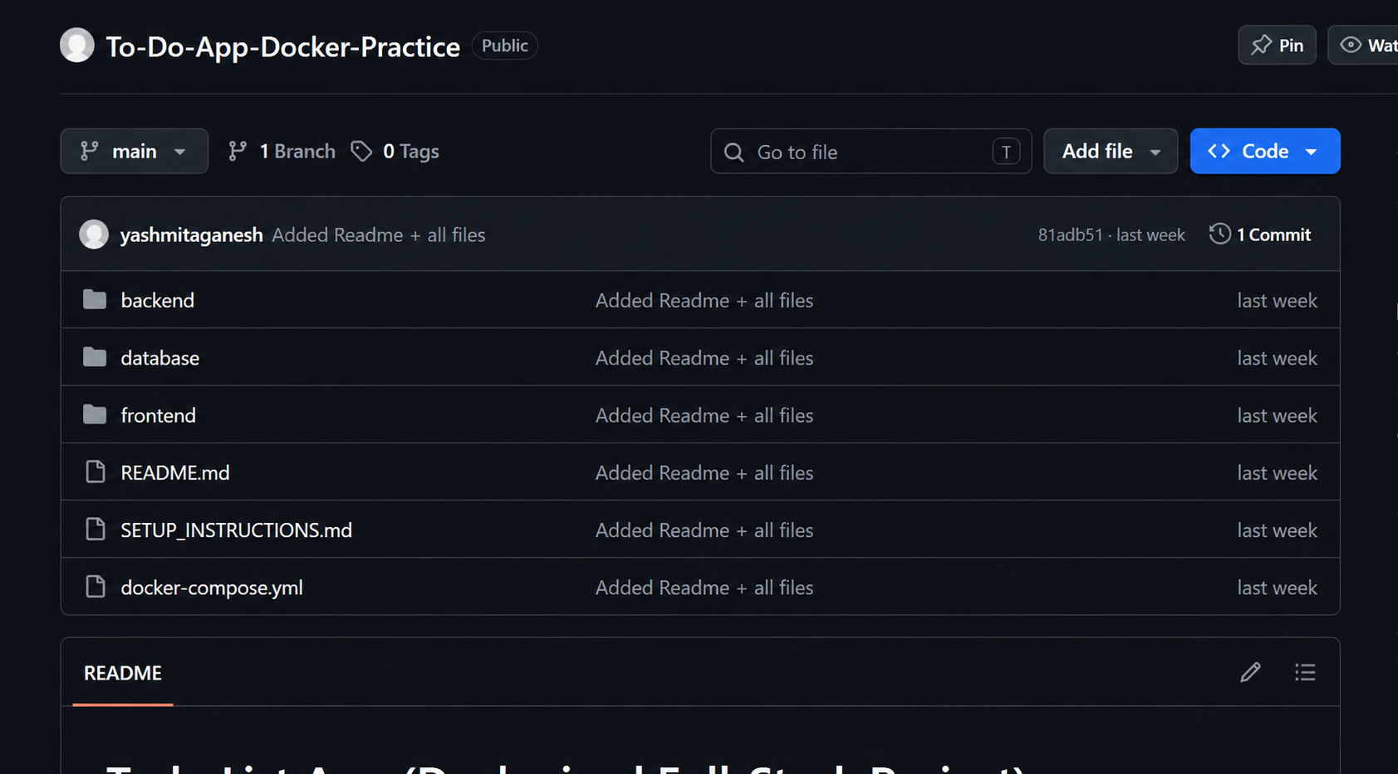

Observation
- The Flask application was created successfully.
- The Docker image was built without errors.
- The container started successfully.
- The application was accessible at http://localhost:5000.
- The Docker image was pushed successfully to Docker Hub.

Result
The Python Flask To-Do application was successfully containerized using Docker, executed inside a Docker container, tested through a web browser, and uploaded to Docker Hub successfully.

